Project Design Phase-II
Technology Stack (Architecture &amp; Stack)

Technical Architecture:
The Deliverable shall include the architectural diagram as below and the information as per the table1 &amp; table 2

Architecture Diagram – BlogNest:

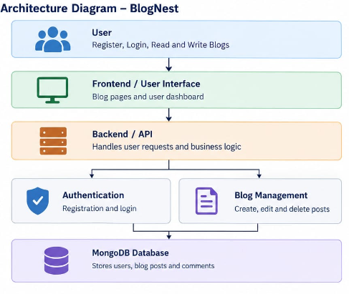
Key Features
- User registration and login.
- Create, publish, edit, and delete blog posts.
- View blogs and search functionality.
- User dashboard to manage personal blogs.
- Secure and user-friendly interface.
- Store user details and blog posts in MongoDB.
- Allow users to share their ideas and information.

Reference: https://developer.ibm.com/patterns/ai-powered-backend-system-for-order-processing-during-pandemics/

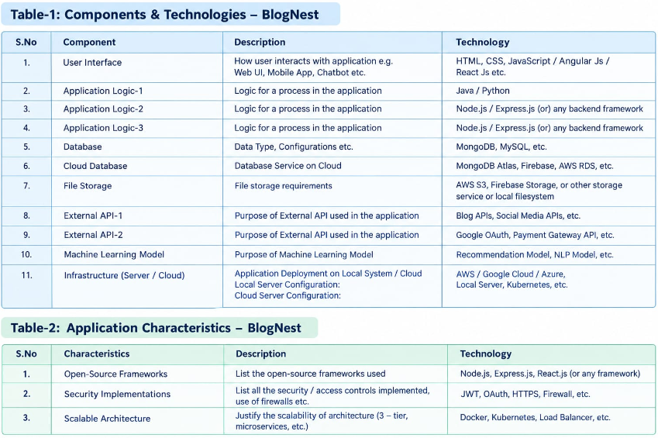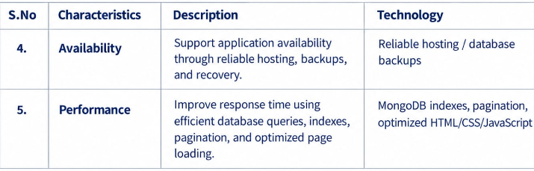

References:
https://c4model.com/
https://developer.ibm.com/patterns/online-order-processing-system-during-pandemic/
https://www.ibm.com/cloud/architecture
https://aws.amazon.com/architecture
https://medium.com/the-internal-startup/how-to-draw-useful-technical-architecture-diagrams-2d20c9fda90d

